Water Guard Cooler Users/
Water Guard Method.

The WATERIDE System will work with 99% of the water dispensers out in the market. Water Guard coolers, are one of the dispensers that need some minor modification in order to be comparable with the WATERIDE System.

Why the WATERIDE does not work properly with the water Guard dispensers?
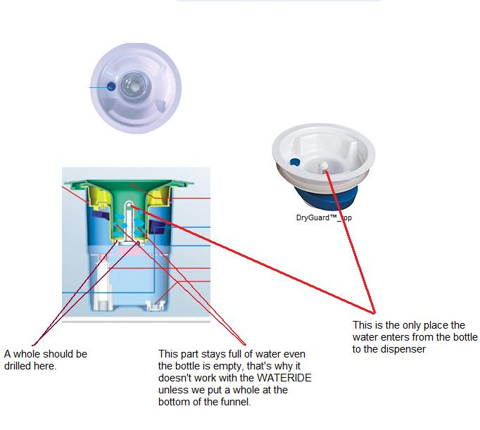
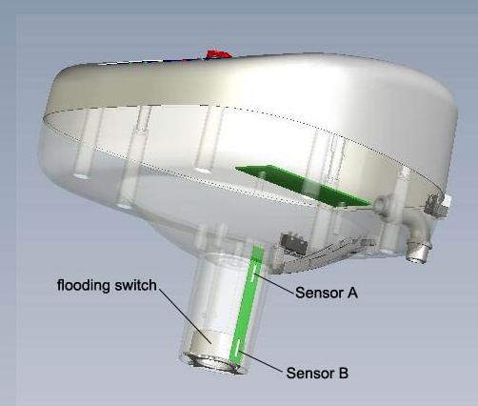
- The WATERIDE consists of many sensors. Sensor A is responsible for deactivating the pump when the flooding switch (water) is leveled with sensor A (figure 1.1). Sensor B is responsible for activating the pump when the flooding switch is leveled with sensor B (figure 1.1). With water guard coolers, the flooding switch stays leveled with sensor A, even though the dispenser water reservoir is empty from the water, the water guard method (such as Oasis coolers), keeps water inside the top portion of the cooler all the times, and that what requires a little modifications for the cooler top part, it only takes 2 minutes.
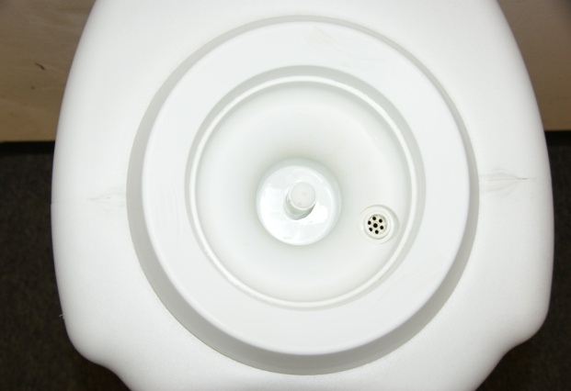
Figure 1.1
Figure 1.2

In figure 2.1, this is how the water guard cooler looks like from the top view.
Before you start this process:
1- Please wash your hand very good, and if possible ware a latex gloves in your hands.
2- After you done with the unit that you working with wash it very good.
- Instruction on how to make the WATERIDE compatible with the water Guard Coolers:
1.1- First, remove any thing from the top of the cooler, and locate the top removable part as you can see in figure 1.2
- Turn clock wise and pull upward to completely remove the water guard unit (figure 1.3a,b).
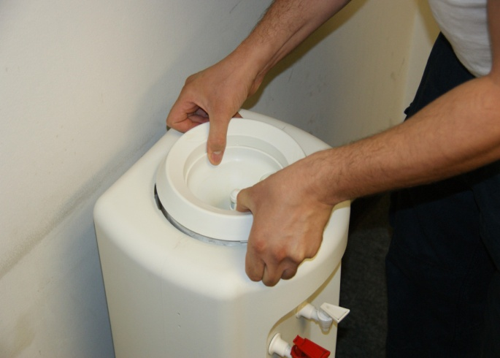
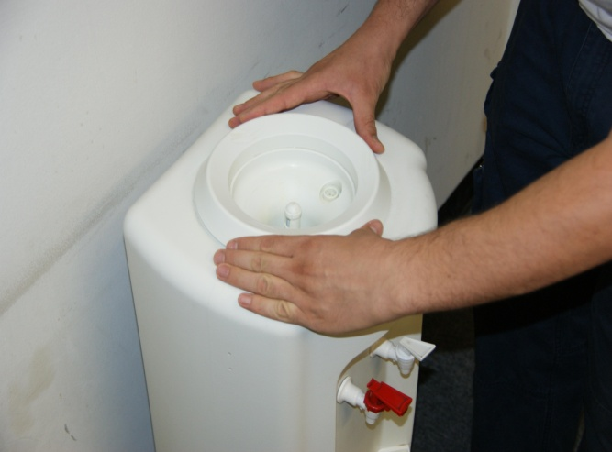
figure 1.3a figure 1.3b
- Now you have separated the water guard unit from the dispenser as you can see in figure 1.3c.
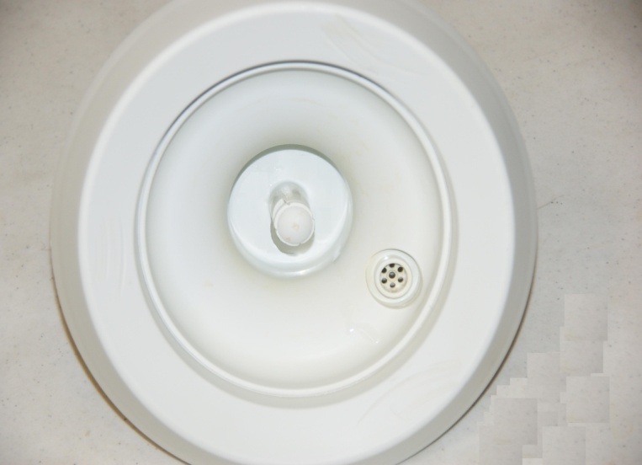
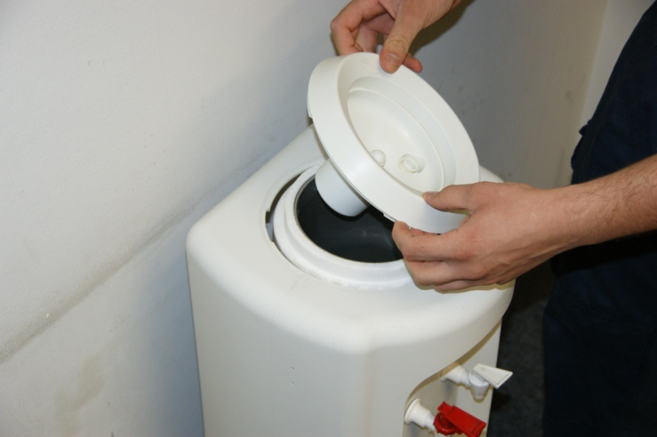
Figure 1.3c
- The water guard unit looks like in figure 1.3d

Figure 1.3d

2.1- Now you have the unit separated, you can use any kind of drill. Drill a 2 holes into the bottom of the water guard unit, you can flip it and drill the holes from the back side, it's much easier , see figure 2.1a & b.
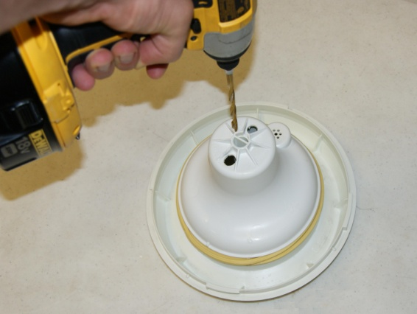
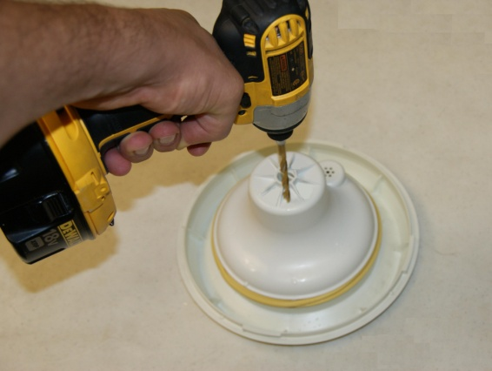

Figure 2.1a Figure 2.1b
- Figure 2.3 is a top view for the water guard unit before and after.
Before After
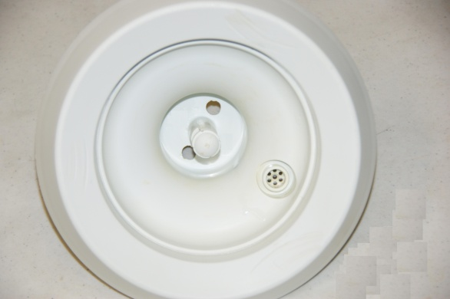
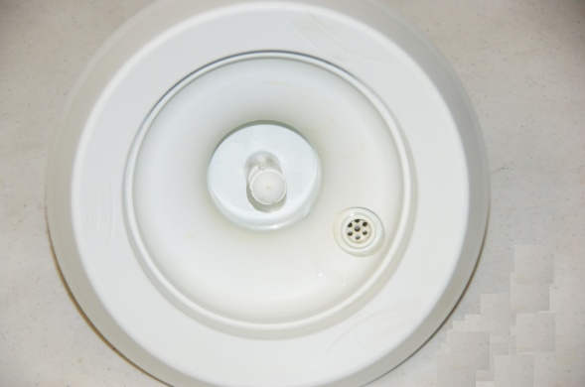

Figure 2.3
- Place the water guard unit back on top of the water dispenser (figure 2.4).
Before After
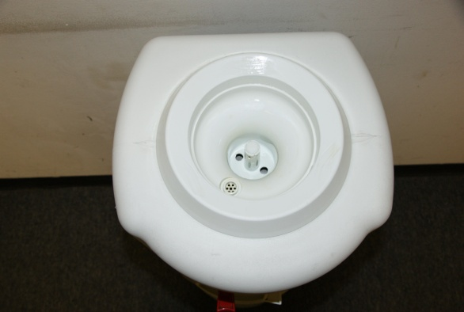
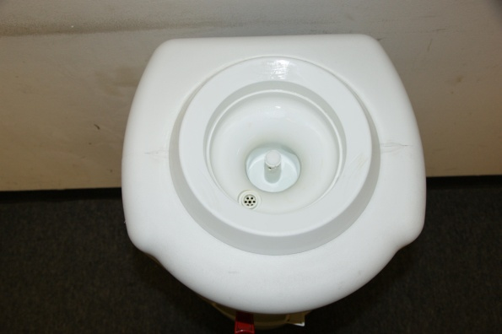

Figure 2.4

